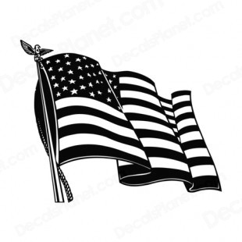
OAK RIDGE MARTIAL ARTS ACADEMY

Flag test study sheet

In order to wear our country’s flag on your uniform, you must first know some background about it. Please study the following history of our flag and then make arrangements to take the Flag Test. If you qualify, you may display the patch on your right arm. The test and patch are free, like our country. Wear it with pride and appreciation, for there is no other place in the world like it.

Designer: The recognized designer of the flag was Francis Hopkinson, a delegate from New Jersey to the Continental Congress and also a signer of the Declaration of Independence.

Stars and Stripes: The Continental Congress resolved on June 14,1777, that the thirteen colonies that originally constituted the United States, be represented by thirteen stripes; that the union be thirteen stars, white in a field of blue, representing a new constellation. No given star on the flag corresponds to a specific state. The stars represent the states collectively.

Flag Colors: The red, white and blue colors and their arrangements on the flag are often interpreted as expressing the very character of our nation. George Washington described the white of the flag as a symbol of our desire for liberty in the land of the free. The virgin white stripes represent the purity and serenity of our nation. The white stars represent purity, liberty and freedom within the nation, which in turn symbolizes the purity, liberty and freedom of each individual American citizen.

The crimson red stripes symbolize the courage and vigilance of the American citizen who is not afraid to stand up and fight for the peace of the American way of life. That is why there are six white stripes bordered by seven red stripes which means there cannot be peace, liberty and freedom within the nation without the American citizen willing to make the ultimate sacrifice, in order to preserve the freedom and peace of this great country for future generations.

The royal blue field stands for freedom and justice. Thomas Jefferson once said that justice is almost one fourth of the things that we as American citizens hold near and dear to our hearts. Without justice we cannot have peace and freedom in our way of life. Therefore, if you measure the flag, the blue field will almost be one fourth of the area of the flag no matter how it is measured.

The United States of America’s flag has changed more often than any other nation’s flag in the history of the world - twenty-seven times since 1776. Currently, there are 50 stars representing the fifty states of our great nation.

We ask that you take the time to think about what it means to be an American and what the flag means to you……

Remember, a journey of a thousand miles begins with a single step……

